People’s Democratic Republic of Algeria
Ministry of Higher Education and Scientific Research
LarbiTebessi University -Tébessa-
Faculty of Letters and Languages
Department of Letters and English Language

Investigating a Decade of Racial Segregation against Blacks in the USA: A Color Blind Police System or Unequal Opportunities, 2010-2020?

A Dissertation Submitted to the Department of Letters and English Languagein Partial Fulfillment of the Requirements for the Degree of Master in Literature andCivilisation

Candidates: Supervisor:
MarouaKATEB Mr. Rabie ABDERRAHMANE
Nourhane BOUHAFARA

Board of Examiners:
President: Mrs.Amina BOUAZIZ(M.A.A), LarbiTebessi University/ Tébessa.
Supervisor: Mr.Rabie ABDERRAHMANE (M.A.A), LarbiTebessi University/ Tébessa.
Examiner: Mr.Naim KHEMMAR(M.A.B), LarbiTebessi University/ Tébessa.

2020/2021

Dedication
I want to thank Allah for always being there for me
I dedicate this work first and foremost to my beloved parents for their love and support throughout my life you two have filled up my world with so much happiness that a lifetime is not enough to enjoy it all. Thank you both for believing in me and for giving me strength to chase my dreams. A big gratitude to my sisters Imen and her little baby Ayan for his pure soul and joy, Kaouther thank you for the positive energy that you gave me after a bad day and I miss you so much and I wish you were here without forgetting my beloved hero my brother Walid thank you for driving me to university every day even if you are tired and making me laugh every day.
To all my friends Chaima, Aya, Marwa ,Khaoula , Manel , Basma, kalthoum, thank you for your understanding and encouragement in my moments , a big gratitude to my beloved partner Kateb Marwa , I can’t list all the names here but you are always on my mind and your friendship makes my life a wonderful experience I also want to thank my dearest cousin for his help thank you Kherie
Nourhane BOUHAFARA

Dedication

All prayers to God Almighty my creator, my strong pillar, my source of inspiration, wisdom, knowledge, and understanding∙
I dedicate this work to my family, my beloved sister KATEB Imen, and my closest friends FERHI Maroua, TRAIA Amina , SLATNI Sarra , SMAALI Zineb who have been always there for me in joy as well as sorrow, those who gave me amazing moments that will be sculptured in my memory forever.
Without their support I could never accomplish this goal.
A special dedication goes to the soul of my dearest friend MESSAI Nour, who left us in the halfway with dreams and ambitious we might be achieving together. She is probably looking down from heaven up above sending smiles. May Allah Bless your pure soul.
A special dedication to my work mate and partner BOUHAFARA Nourhane.
for his appreciated effort who has been a good example of responsibility, guide and support
To all the people in my life who touch my heart.
You have successfully made me the person I am becoming.
Maroua KATEB

Acknowledgments
“In the name of ALLAH, The Most Compassionate, The Most Merciful”
Thank the Magnificent God that blessed us with His patience so that we could make this humbly executed work in its current shape. We owe profound appreciation and gratitude for our respectable and ideal supervisor “Mr. ABDERRAHMANE Rabie” for granting us the honor to be his supervisee. And guided this research and gave us his time and expertise. We thank him not only for his comments and valuable suggestions, but also for his encouragement and understanding, we place on record our special gratitude to the jury committee: Mr. Naim KHEMMAR and Mrs.BOUAZIZ Amina, who have allocated some of their precious time to read, evaluate, and constructively review our work. We take this opportunity also to express gratitude to all the staff of the Department of English and the Faculty for their assistance and support. Thanks to our family and closest friends for the unceasing encouragement, support and attention. We also place on record our sense of gratitude to one and all, who directly or indirectly, have lent their hand in this work. We are sincerely grateful.

Abstract
The present dissertation examines a decade, 2010-2020, of racial segregation against Blacks in the USA. The slave born society, modern USA, seems to have left a legacy behind. Though slavery was abolished in 1865, colored people are still struggling today to enjoy the social freedoms and rights of their White fellow citizens. This work aims to gauge, the social circumstances of Blacks, the training and practices of the police force and there relation if any with the high rate of incarcerations of Blacks compared to Whites and other ethnic minorities. A combination of qualitative, quantitative and historical methods are administered to analyze the data extracted from a variety of interviews, polls, researches and surveys along with tracing back the recent events to the early days of slavery. The findings revealed that the status quo of Blacks; less educated, fewer opportunities to get a job that would cover their basic needs and get them out of the circle of poverty, combined with a biased dominantly White, ill-trained police force have contributed enormously to the over representation of Blacks in prisons. Though the racial bias police training was created to curb police abusive use of power against Blacks, the numbers do not consolidate its efficiency. Hence, more in-depth investigations are to be carried out to address police practices and training.

Résumé
La présente thèse examine une décennie, 2010-2020, de ségrégation raciale contre les Noirs aux États-Unis. La société née d'esclaves, les États-Unis modernes, semble avoir laissé un héritage derrière elle. Bien que l'esclavage ait été aboli en 1865, et les personnes de couleur luttent encore aujourd'hui pour jouir des libertés sociales et des droits de leurs concitoyens blancs. Ce travail vise à jauger, la situation sociale des Noirs, la formation et les pratiques des forces de police et leur relation s'il y a lieu avec le taux élevé d'incarcérations des Noirs par rapport aux Blancs et autres minorités ethniques. Une combinaison de méthodes qualitatives, quantitatives et historiques est administrée pour analyser les données extraites d'une variété d'entretiens, de sondages, de recherches et d'enquêtes, tout en retraçant les événements récents jusqu'aux premiers jours de l'esclavage. Les résultats ont révélé que le statue des Noirs ; moins instruits, moins d'opportunités d'obtenir un emploi qui couvrirait leurs besoins fondamentaux et les sortirait du cercle de la pauvreté, combinés à une force de police à prédominance blanche et mal formée ont énormément contribué à la surreprésentation des Noirs dans les prisons. Bien que la formation policière aux préjugés raciaux ait été créée pour freiner l'utilisation abusive du pouvoir par la police contre les Noirs, les chiffres ne consolident pas son efficacité. Par conséquent, des enquêtes plus approfondies doivent être menées pour examiner les pratiques et la formation policières.

ملخص
تدرس هذه الأطروحة التحيز العنصري ضد السود في الولايات المتحدة الأمريكية على مدى العقد الممتد من 2010 إلى 2020. و يبدو أن المجتمع المتولد من العبيد في الولايات المتحدة الأمريكية الحديثة، قد خلّف وراءه إرثا؛ فعلى الرغم من إلغاء العبودية سنة 1865، لا يزالا الأشخاص ذوي البشرة السوداء يكافحون من أجل التمتع بالحريات الاجتماعية و الحقوق التي يتمتع بها المواطنون البيض. يهدف هذا العمل إلى تقييم الظروف الاجتماعية للسود، تدريب و ممارسات الشرطة و علاقتها، إذا ما وجدت، بارتفاع معدل سجن السود مقارنة بالبيض و الأقليات العرقية الأخرى. تم اعتماد منهجية كمية و نوعية و كذا تاريخية في تحليل البيانات المستخلصة من مجموعة مقابلات، استطلاعات رأي، أبحاث و دراسات استقصائية مع تتبع الأحداث الأخيرة إلى غاية الأيام الأولى للعبودية. كشفت النتائج أن الوضع الحالي للسود المتمثل في قلة التعليم، قلة فرص العمل الذي من شأنه أن يسمح بتغطية حاجياتهم الأولية و إخراجهم من دائرة الفقر، علاوة على الشرطة المنحازة المتكونة من أغلبية بيضاء سيئة التدريب، كل هذا ساهم بشكل كبير في ارتفاع عدد السود في السجون. و رغم أن تدريب الشرطة على التحيز العنصري خلق ليحدّ من استعمالها المفرط للقوة ضد السود، فإن الأرقام لا تدعم بشكل كاف كفاءة هذا التدريب، و منه لا بد من القيام بتحقيقات عميقة في ممارسات و تدريبات الشرطة..

Table of Contents
Dedication…....…………………………….……………………………...…………………. i
Acknowledgments…………………………………….……………………………………. iii Abstract………………………………………………….……………………………….… iv Résumé…………………………………………………………..……..…………….…….... v
ملخص.................................……............…...................................................………...….…..... vi
Table of Contents………………………………………………………………….......….... vii
List of Acronyms and Abbreviations ……………...……...…………………...………….. ix
List of Figures……………………………………………………………………….………..x
Introduction 1
Chapter One: Historical Overview: From Slavery to Segregation…………..……………5
1.1. The Concept of Slavery 6
1.2. The American Civil War 7
1.3. History of Segregation in America 8
1.3.1. The American Civil Rights Movement 9
1.3.2. Civil Rights Acts 9
1.4. The Most Important Events that Happened to Blacks from 2010 to 2020 14
Chapter Two: Investigating the Manifestation of Racial Discrimination:Poverty, Employment, and Education.. ……………………………………...………………………19
2.1. Poverty and African Americans in the United States 19
2.1.1. The Persistent and Widening Racial Wealth Gap 20
2.2. Employment of African Americans in the United States 23
2.2.1. African American Face Systematic Obstacles to Getting Good Jobs 23
2.2.2. Black Workers Have Higher Unemployment Rates than Whites 24
2.2.3. Black Workers Have less Access to Jobs than Whites 26
2.2.4. The Opportunities of Well-Paying, Stable Jobs with Decent Benefits to Black Workers ……………………………………………………………………………….....27
2.2.5. The Racial Wealth Divide is Widening 29
2.3. African American Education in the United States 31
2.3.1. Blacks and Whites: Still Separate, Still Unequal 31
2.3.2. Understanding the Racial Discipline Gap in Schools 32
Chapter Three: Ethnic Disparity in State Prisons with Color-Blind Police Practices.....35
3.1. The Roots of Racial Bias to the Over Representation of Black in Prisons 35
3.2. Police Violence and Black People 38
3.3. Racial Color – Blind Issues in American Police Training and Practices 41
3.3.1. A Probe into Police Practices 41
3.3.2. Exploring Police Training 45
Conclusion 49
Works Cited 52

List of Acronyms and Abbreviation
NAACP: The National Association of Colored People's Advancement
N.Y: New York
NYPD: New York City Police Department
MIA: the Montgomery Improvement Association
W. E. B. Du Bois : William Edward Burghardt Du Bois

List of Figures and Tables
List of figures
Figure 1. The Investigation of Wealth and Income of African Americans During 2010 -2016.
Figure 2. Poverty Rate by Race and Hispanic Origin 2010 to 2020.
Figure 3. Different Unemployment Rates over Multiple Categories.
Figure 4. White Workers Have More Employment Opportunities than Black Workers.
Figure 5. The Earn of Black Workers across Subpopulations.
Figure 6. The Time spend Looking for Jobs Between Blacks and Whites.
Figure 7. The Racial Wealth Gap since the Great Recession.
Figure 8. Percentage of Public Elementary and Secondary School Students, Race/Ethnicity.
Figure 9. Scented Prisoners by Race 2010-2019.
Figure 10. Policing Force in Answering 911 Calls.
Figure 11. Blacks and Whites Interactions with Police Officers.
Figure 12. Black Americans Experiences of Racial Discrimination.
Figure 13. Officers Behaviours about Implicit Bias Training.
Figure 14. Police Force Actions towards Black People .
Liste of Tables
Table 1. Black Americans Experiences of Racial Discrimination.
Table 2. Police Force Actions towards Black People

Introduction
Blacks and Africans in America, these laws vary in their view of slaves and how to deal with them. Despite the creation of non-discrimination laws as a basic principle on which international law is based, the persistence of racism and racial discrimination There was forced immigration of African slaves who did not immigrate but rather experienced forced displacement as a result they suffered a period of disenfranchisement, prejudice, and discrimination that started at the very beginning in America it took a long period full of discrimination, torture, violence, and master's control toward slaves. Till the last drop of blood slaves were fighting for their freedom until the Emancipation Proclamation was signed by Abraham Lincoln declaring that all salves shall be free . But despite the elimination of enslavement exploitation and inequality Black Americans that still face the problem of the color line and racial treatment through different walks of life.
America was built on the oppression of African Americans. Since the creation of America, especially from 2010 to 2020 this period shows the world the difficulties African Americans face to live a normal life in the existence of racial discrimination and a series of persecutions to which Blacks were subjected in their daily lives. The latter was enough to affect their image in the American society to become linked to crimes and color line problems only the American society known by racial beliefs, but it was normal to act through police officers by treating Blacks as a threat and suspects.
In recent years, cases in which African Americans were killed by the police have risen to national prominence and increased racial tensions, often prompting demonstrations and protests around the country. These several crimes paved the way for the appearance of the Black Lives Matter Movement that was created to speak out against police killings of African American people. and broader issues such as racial profiling, police brutality, and racial inequality in the United States's criminal justice system also this movement encouraged many scholars to conduct numerous studies to check on police practices and training by making bias training test to find a solution to this issue.
This research investigates the position of Blacks as a persecuted minority in the American society.The innovative aspect of our research focuses on the racial segregation against Africans Americans in the United States and the unequal treatments of Africans Americans from 2010-2020.What happened to African Americans when they were brought to America? did the abolition of slavery really affected their lives? And how Whites dealt with this situation.The study aims is to cover the status of African-Americans after the abolishment of slavery, ratification of Amendments to segregation, the enactment of Civil Rights Acts, and the effects of discrimination on the African Americans during 2010-2020 period. The research also focuses on the ethnic disparity in state prisons with color blind police practices and training.
In order to achieve the main objectives of this dissertation, variety of methods were used. Initially the descriptive method to examine the situation of African-Americans and how did their position change through time from being salves to being American citizens, as well as Whites' treatment to them, and how police violence was used against Africans Americans. The research also used the historical approach, and it used this approach in order to draw a historical background about the case on the one hand.from the other hand, the approach aims to come out with a clarification of African-Americans’ situation in the American society. The mixed method was also used; the qualitative research was in the descriptive method to understand the data extracted. The qualitative method was conducted through relying on the analysis of books , articles and study of different graphs during 2010-2020, in addition to watching various videos on the subject of study .
Many historians wrote about American history and focused on ethnicity in American society by introducing a clear image of African American sufferance. Therefore, numerous studies and researches were conducted to show the battle that every Black faces every day to survive from racial discrimination in America. Authors like Solomon Northup in his book Twelve Years a Slave presents a startling depiction of the common slave experience in the United States by showing basic facts about enslavement and all slaves' sufferance. Another book by Vally Richard entitled The Tow Reconstructions: The Struggle for Black Enfranchisement shows the aftermath of the Civil War in ending slavery with the Emancipation Proclamation that was signed by President Abraham Lincoln. Several works are relevant and essential to comprehend the broken connection between the police and ethnic groups and public anger at the murder of George Floyd and other African Americans. Khalil Gibran Muhammad’s “The Condemnation of Blackness: Race, Crime, and the Making of Modern Urban America” describes the creation following slavery of a racist ideology that framed African Americans as dangerous and likely criminals with unequal opportunities that mindset animated laws, policies, and aggressive police practices that criminalize, incarcerate, and lead to the killing of disproportionate numbers of African Americans. Furthermore in order to understand race relations in America White Fragility: Why It's So Hard for White People to Talk about Racism by Robin Di Angelo that articulates the need for White people to understand and discuss racism is a great place to start. Also The New Jim Crow: Mass Incarceration in the Age of Color blindness by Michelle Alexander is one of the most influential books that highlights the criminal justice and mass incarceration during Obama’s presidency.
The scope of this research is ordered in three main chapters. The first chapter entitled;
“Historical Overview: From Slavery to Segregation.” It discusses the story of how Blacks lived under pressure and the kind of violence used against them in the past, and they are still fighting to gain their freedom and to preserve their positions in the American society, it also provides an overview about bringing Blacks as salves into the lands and their struggle for freedom lately. It is divided into four sections, they talk about The American Civil War which discusses the ultimate causes that led to the bloodiest war in the United States, and The Civil Rights Movement and its impact on African American. It tackles the great obstacle of African-Americans, which attempted to end segregation and discrimination against Black race as well as having equal Civil Rights like any normal citizen in the American society. Moreover, it covers the most important events that happened to Blacks from 2010 to 2020. It depicts the crimes endured by the Afro-Americans and their situation in the United States.
The second chapter entitled “Investigating the Manifestation of Racial Discrimination Poverty, Employment, and Education.” African Americans have experienced negative assumptions in the period of time under investigation (2010-2020). These inequalities negatively affected the lives of Black people in a number of ways, which led them to face higher unemployment. Additionally, it discusses the different living conditions between Black and White students during their school years and their chances of having a good education.
The last chapter entitled“Ethnic Disparity in State Prisons with Color -Blind Police Practices” it covers the difficulties that Blacks faced at some point during their life, which can lead to committing illegal crimes. These difficulties can be traced in education, employment and social status. It highlights police major racial bias against Black minority. It dives also into police racial practices against Black minority that can well be behind the high rate of incarcerations and possibly the increasing number of Black deaths. The latter lead most researchers to question police excessive use of force and to look for a solution to remediate this problem.

Chapter One
Historical Overview: From Slavery to Segregation
The starting point of slavery in the Americas was first witnessed during the 17th and 18th centuries. Blacks played an important role in the history of the United States that lead to their status quoin America. They lived under pressure and violence was used against them in the past and the present is not different, Blacks still fight to gain their freedom and to preserve their positions in the American society. Hundreds of years of slavery were abolished consequent to the Civil War or the War of States that was a watershed moment in American history. It shaped the American society to the point that some African American historians such as Frederick Douglass and Harriet Beecher Stowe, claimed that slavery was the root cause of the Civil War (Onion et al. “Harriet”).
The claim that slavery was over is not valid by the same historians, they believe it only changed its practices to segregation, which typically refers to the "Jim Crow" laws of segregation and disenfranchisement embodied a systematic codified regime of racial exclusion that governed the American South for three-quarters of a century starting in the 1890s. The laws mandated segregation in colleges, parks, libraries, drinking fountains, restrooms taxis, trains, and restaurants, among other places. It was clearly shown that Blacks are not equal to Whites; they separated them in all aspects of life (Jim Crow).
After decades, the definition changed and segregation became not only about peaceful separation, it was also a way of practicing heinous crimes against humanity. Just to name a few examples, what happened to Trayvon Martin (2012), Michael Brown ( 2014), Tamir Rice (2014), Eric Garner (2014) Laquan McDonald (2014), John Crawford (2014) Freddie Gray (2015), Walter Scott (2015), Alton Sterling (2016), Philando Castile (2016), Terence Crutcher (2016), Antwon Rose (2018) and George Floyd in (2020).
The following chapter discusses the beginning of slavery in America, focusing on the major significant events that lead to this phenomenon, as well as, the consequences of the American Civil War and how Black Africans status quo changed from being enslaved to become American Citizens and their struggle to gain liberties and freedoms enjoyed by their White counterparts.
  - The Concept of Slavery
Slavery history is a vast unforgettable history of tragedy and brutality, which crosses both ages and continents, that contributed to founding the colonies of the new world. The African Americans life in the United States was shaped by migration most of which was forced by slave trading to the Americas that is considered as the turning point of American history. This story started with the first 20 slaves who were brought to the Americas, to the White lion in the Virginia colony in 1619 (Lynch).
Slavery in its real terms refers to the forced labor that served as indentured servants in the New World, specifically in the Southern colonies. Those servants were called property by their owners and they could be traded. (Buell 9).The majority of slaves farmed from sunrise to sunset on small farms of tobacco fields, the place where men were most needed for hanging, drying, and packing tobacco, as well as building. However, women’s work included helping with cooking, laundry, gardening, and babysitting. The long period of slavery resulted in 12 generations of Black slaves who produced enormous wealth for slaveholders. Slavery was the backbone of agriculture as an industry, securing labor, hence strengthening the South’s mainly agriculture-oriented economy (“plantation”).
Since there were no machines to help with the physical work at that time, Landowners and merchants needed laborers to do the job in their plantations on their behalf, hence, they employed poor Black people to do the job against providing food and shelter instead of money despite the hardships and bad conditions they encountered. In addition to that, African-Americans dominated much of the labor on Southern plantations from cash crops of tobacco, cotton, and rice, and the invention of the Cotton Gin, which boosted cotton cultivation and sold it in Europe and North America. The latter was the primary reason for the rise of slavery in the South (Paterson 6-8).
1.2 The American Civil War
The Civil War was the most important event in American history that was described by historians as the conflict that created a nation. Additionally to this description, most historians alive today are still debating the ultimate causes that led to the bloodiest war in the United States. Declaring that the Civil War started because of unpromising differences between the free and slave states over the power of the national government to prohibit slavery in the territories that had not yet become a state James McPherson and David Goldfield wrote that "both Northerners and Southerners recognized slavery as the immediate cause of the Civil War." In addition to both authors opinion, Abraham Lincoln during his presidency declared that "one eight of the whole population were colored slaves, not distributed generally over the union, but localized in the Southern part of it"(Green). This warfare lasted for four years and it had over 10,500 military engagements and it began when the confederate’s bombarded the Union soldiers in South Carolina on April 12, 1861 and it ended in spring 1865 leaving approximately 620,000 deaths (“Civil War”).
During the third year of the bloody Civil War between the North and the South, Abraham Lincoln issued the Emancipation Proclamation, on 1 January 1863 stating that"All persons held as slaves within the rebellious states are, and henceforward shall be free"(“Civil War”).With the issuance of this document, Black people both free and runaway slaves volunteered for the Union army and by October, the same year, approximately 180,000 African American joined the army and worked as scouts, nurses, spies, cooks, and laborers.This reaction affected the South’s war effort and reinforced the Union army by increasing manpower. The Emancipation Proclamation was a vital step toward abolishing slavery and freed 3,1 million out of 4 million slaves. Besides, America gained the victory of the Union in the Civil War by changing it into a war of freedom by adding force in military Even though the Emancipation Proclamation was not enough to free all the slaves because of its main focus on the military victory of the Union, president Lincoln recognized that his document needs to be followed by a constitutional amendment to free all the slaves. After a year of work, finally, the efforts of the United States president met with success when the House Representatives passed the bill in January 1865. It consists of 13 amendments that were created to abolish slavery, and emancipate all slaves all over the country. Thanks to the 13th amendment, slavery is nowhere to be seen in the states for over 100 years now. Thought gave every Black the right to be free but although there were several attempts to end racial inequality and to accept Black people in America with arms wide open, the American society inherited slavery legacy in a form of social segregation and every Black in America is fighting the battle of racism (“Civil War”).
1.3 History of Segregation in America
Racism has been defined in many ways according to many social scientists. The concept of racism cannot be defined without acknowledging that the meaning of race was first used to describe the differences between people's origin; skin, color and culture. Wilson defined racism as" an ideology of racial domination... ". In other words, White people take the superiority in society rather than Blacks, whereas racism is commonly defined as beliefs, practices, and activities that result in the unfair treatment of people of other races and it is also known as the belief that each race has distinct and inherent characteristics (Wilson).
Besides all of the several attempts of the government, America still faces a color line dilemma and the situation of the Black assecond-classcitizens. The increasingly Black lower classes are worse in towns across the country and in rural areas of the old South. Although knowledgeable people deny it, there are discussions of what can and should be done about it. People seriously deny crimes, drug abuse, family breakdown, unemployment, poor education, welfare dependence, In addition to that, the Eminent Negro Man of Letters W. E. B. Du Bois predicted in 1903 that the issue of the 20th century would be the problem of the color line and he proved it right.Today’s socialist claim that modern racism is a legacy of slavery but in a systematic way (Wilson).
1.3.1 The American Civil Rights Movement
The American Civil Rights Movement was a nationwide political movement in the South of the United States against racial segregation and injustice that gained national attention in the mid-1950s. This revolution arose from the centuries-long attempts of enslaved Africans and their descendants to combat ethnic injustice and eliminate slavery. Once enslaved people were emancipated as a result of the Civil War and then granted universal Civil Rights by the Fourteenth and Fifteenth Amendments to the United States Constitution and the efforts to obtain federal protection of these rights continued for a century there after. Moreover, The Civil Rights Movement was a fight for social justice that mostly existed in the 1950s and 1960s for African Americans to achieve equitable legal rights in the United States. Slavery had formally ended as a result of the Civil War, however, it did not bring an end to segregation against Black people, and they continued to experience the crippling consequences of racism especially in the South. By the mid-twentieth century, Black Americans had aplenty of racism and abuse aimed at them, along with many White Americans, organized and waged an epic two-decade fight for equality(“Civil Rights Movement”).
1.3.2 Civil Rights Acts
December 1, 1955, when Segregation laws at the time stated that all Black passengers must sit in designated seats at the back of the bus, As usual, a Black woman named Rosa Parks took her Montgomery Bus. She was seating in the allocated seats to coloured people until a White man boarded the bus and could not find a seat in the designated area for Whites. The driver asked Parks, along with three other Black passengers, to vacate their seats but she refused. Consequently, she was arrested. When spread, the news of her arrest sparked anger and support. Parks indirectly became known as the "mother of the early Civil Rights Movement." (“Civil Rights Act”). The Black community activists founded the Montgomery Improvement Association (MIA), headed by Baptist minister Martin Luther King, Jr., a position that would put him at the forefront of the Civil Rights Movement. Additionally, the MIA was inspired by Parks' bravery to lead a bus boycott of the Montgomery bus system. The Montgomery Bus Boycott was in effect for 381 days and The Supreme Court ruled on November 14, 1956, that segregated seating was unconstitutional (“Civil Rights Act”).
Moreover, in 1954, Brown v Education Board of Topeka was a significant 1954 case of the Supreme Court in which the judges unanimously held that child racial discrimination was illegal in public schools. Brown v Education Board was one of the key elements of the Civil Rights Movement helping to set the principle that “separate-but-equal” education and other programs were in reality not equal. Consequently, the Civil Rights Movement gained popularity when the United States Supreme Court made segregation of public schools illegal in the case of Brown v. Board of Education (“Civil Rights Act”).
One year later, a High School in Little Rock, Arkansas, requested volunteers from all-Black high schools to join the formerly segregated school in 1957. On September 3, 1957, nine Black students, called the Little Rock Nine, assembled at the Central High School to start classes but instead encountered a shouting, attacking crowd Guard. The students attempted again and managed to get inside a few weeks later, but had to be stopped for security reasons after being threatened. The latter urged President Dwight D. Eisenhower to order the federal military to take the students from the Central High classes because they were constantly harassed and harmed. In addition to this incident, though all Americans have the right to vote based on the Fifteenth Amendment in the constitution; it was made difficult to Blacks to vote just imposing a literacy test to color voter that is deemed confusing, dishonest, and impossible to pass. The Eisenhower administration forced Congress to consider new Civil Rights laws which consider the demands of the Civil Rights Movement and reduce racial tension in the South. The latter culminated with the first new laws on Civil Rights since reconstruction have been signed by President Eisenhower on 9 September 1957, the Civil Rights Law of 1957. It permitted the federal prosecution of anyone who wishes to prevent an individual from voting. It also set up a committee to investigate voting abuse .Despite making some progress; Black Americans frequently faced racial discrimination in their daily lives. On 1 February 1960, in Greensboro, North Carolina, 4 college students stood up to refuse to leave their lunch desk without being served. Hundreds of persons joined their cause in the so-called Greensboro Sit-ins in the next few days. Following some students being arrested and charged with infringement, protesters started a boycott of every secluded lunch counter before the owners were smashed out and the four original students had been at the lunch counter in Woolworth for the first time (Clark).
On 4 May 1961, a Greyhound bus in Washington, DC was being set up by 13 Freedom Riders, seven Black and six White demonstrators, on a tour of South America protesting against separate bus terminals. They were examining the 1960 Supreme Court ruling in Boynton v. Virginia, which ruled unconstitutional the separation of interstate transport services. The Freedom Rides brought public attention to the brutality by both Black officers and White protestors.To Alabama on the day of Mother's Day, 1961, where a crowd boarded the bus and threw an attack. The Riders of Freedom fled from the truck but had been hit badly. Photos were widely distributed of the bus burning in flames, and the crew could not locate a bus driver to take them home. United States Attorney General Robert F. Kennedy arranged a fitting driver with Alabama Governor John Patterson, and Freedom Riders returned on 20 May under police escort. But, when the officers arrived in Montgomery. On 24 May 1961 hundreds of supporters were encountered, the party was arrested and sentenced to 30 days' imprisonment for attacks in a "White only" facility. The National Association of Colored People's Advancement (NAACP) lawyers took the matter to the United States Supreme Court, which overturned the convictions. The cause has been drawn by hundreds of New Riders, and the journeys have begun. The Interstate Commerce Commission published rules banning the segregation of intergovernmental terminals in the fall of 1961, under pressure from the Kennedy administration (Onion et al. “Freedom”).
Lyndon B. Johnson signed the Civil Rights Act into law on July 2, 1964, which was a better version of what President John F. Kennedy had proposed the previous summer before his assassination in November 1963. The Act gives the federal government the ability to restrict racial discrimination in housing, voting, and public accommodations. Despite its controversial nature, the act was a significant accomplishment for the Civil Rights Movement, although this act was the most expansive Civil Rights law passed since reconstruction. It outlaws all forms of discrimination based on ethnicity, color, faith, or national origin (Civil Rights Act).
After two years from outlawing all forms of discrimination, on March 7, 1965, John Lewis 25-year Black man who was inspired by Martin Luther King Jr led a 50-mile march with over 600 marchers from Selma to Montgomery, Alabama to protest the killing of Black Civil Rights activist Jimmie Lee Jackson by a White police officer, and to encourage legislation to enforce the 15th amendment. As protesters approached the Edmund Pettus Bridge, the State of Alabama and local police sent a vocal opponent to the disintegration, Governor George C. Wallace. Protesters refused to hold back and were brutally beaten and tear gassed and hospitalized by the police and dozens of protesters.The entire incident was broadcast and became known as “Bloody Sunday.” Some activists tried to respond with brutality, but Luther King called for peaceful protests and soon won federal security for another march.President Johnson adopted the Civil Rights Act of 1964 on 6 August 1965 in several phases. The new legislation prohibited all assessments of voting literacy in some electoral jurisdictions and offered federal examinees. The Attorney General has permitted state and local poll taxes to be challenged. Consequently in the Harper v. Virginia State Election Board of 1966, polling taxes were later ruled unconstitutional (Klein).
In the late 1960s, two of the Civil Rights leaderswere tragically affected by the Civil Rights Movement. On February 21, 1965, the rally assassinated Malcolm X, former Leader of Islam Nation and Organization of the Afro-American Unity. Martin Luther King, Jr. was assassinated on the balcony of his hotel room on April 4, 1968, by the Civil Rights Activist and Nobel Peace Prize laureate. Emotional plunder and protests ensued and the Johnson administration was pressured ever more to pass new Civil Rights legislation. After that, the Fair Housing Act became law on April 11, 1968, just days after King’s assassination. It stopped housing segregation based on ethnicity, sex, national origin, and religion. In the age of Civil Rights, that was the first law (“Civil Rights Act”).
Many major figures played a vital role in supporting the Civil Rights Movement, opening the doors for future generations to unite. For instance, Rosa Parks who refusedto give up her seat to a White man, on an Alabama bus in 1955, believing that it is humiliating, consequently a boycott to using the Alabama services started (Rosa). President John F. Kennedy the 35th President of the United States and a strong defender of the Civil Rights Movement. After the Birmingham protests, Kennedy publicly began helping the Civil Rights Movement, even though that he risked losing the following election.Also, hehad ambitions to improve the Civil Rights. Unfortunately, he did not live to see the Civil Rights act of 1964 as he was assassinated only a few months after the March on Washington in 1963(John F).
Martin Luther King , is yet another remarkable activist who encouraged and motivated the American people to recall their origins and the realities on which they were formed. He was the Civil Rights Movement's champion in the 50s and 60s, better known for his respectful approach to African Americans' racism. He organized nonviolent protests, marches, boycotts, and strikes, and he refused to follow rules that he believed were wrong and unequal. He is also known of his speeches, including his most famous speech "I Have a Dream . . . ",which stole the hearts of Americans by inspiring a shift in behavior and mentality toward African Americans. He was assassinated in April 4,1929 (Martin).
The Civil Rights Movement had a significant influence on the American society, though its effects were gradual. Before the Civil Rights Movement, African-American residents were not treated fairly in schools, public places, or on public transportation. However, Now that segregation is considered unconstitutional, African-Americans started receiving somewhat fairer treatment.
1.4 The Most Important Events that Happened to Blacks from 2010 to 2020
Several years on, after President John F. Kennedy's death, not much has happened in favor of Blacks, and the racial bias issue received little attention up to 2009. However, with the coming of the presidential election that ended with Barack Obama as the first African American president in the United States’ history compared to the previous president, Obama gained a lot of support from the African Americans and most of them were optimist about the election of the first Black president. The latter had raised expectations of a better race relation among Blacks. But after a series of high- profile deaths during encounters with police, race relations during Obama’s presidency was described by many Americans particularly Blacks as generally bad(“How America”).Consequently, this paved the way for the creation of Black Lives Matter which is an international social movement that was created to fight the colour-blind social system. This social movement has not been shown from anywhere to take up the position that the Movement for Civil Rights has abandoned, but it has taken a sequence of phases and crimes against Blacks namely Trayvon Martin's death in 2012 overloaded the cup. The killing of the 17 year-old boy triggered media outbursts, and nobody could talk about him, thanks to the responses of the people who watched the shooting. George Zimmerman was charged with murder but acquitted at trial after claiming self-defense. This incident was similar to the others and most of African Americans considered it as an act of racism (Black Lives Matter).
Trayvon's death was described by social mediaas a truly catastrophic occurrence, and as a reaction to this crime, three Black female activists initiated using the social media hash tag #BlackLivesMatters on 2013.Their idea started to gain attention on social media and people revolved around the cause and gave some hope that they may change the de facto status quo of Blacks in the states. In addition to this crime, another death of the 18-year-old Black man named Michael Brown helped the movement to gain even more attention and move to the action stage.
The overall goal of the Black Lives Matter Movement is to combat the colour-blind racism in the American society trying to make changes in the criminal justice system. Furthermore, there is a wider context in the history of Black men and women who were murdered at the hands of police officers. Almost every year social media publish several deaths of African Americans with different stories but similar end. Just to name a few, Tamire Rice , the 12-year-old boy, died on November 22, 2014 after being shot by police in Cleveland, after carrying what turned out to be a replica gun in a playground. On the following year, in South Caroline,On April 4, 2015, the residents of the area woke up on the news of an unarmed Black man named Walter Lamar Scott being shot by a police officer, Moreover another victim in 2016, Philando Castile, was shot and killed in traffic by policemen.Other high profile deaths include Alton Sterling (2016) in Louisiana, Philando Castile (2016) in Larpenteur Avenue, Terence Crutcher (2016) in Tulsa, Antwon Rose (2018) in East Pittsburgh. Black women and girls are no exception, they are often targets of police brutality, including Sandra Bland (2015), Deborah Danner (2016), and Atatiana Jefferson (2019), and Breonna Taylor (2020) (Black Lives Matter).
Although most of the deaths have been recorded, it was very rare for police officers to be investigated, charged, or for excessive use of force to be punished. The recordings of Eric Garner, a 43-year-old African American, a father of six children, known in his Staten Island society as a "neighbourhood peacekeeper” and the story of his death on July 17, 2014 at the hands of two of the New York Police Department officers, is a very good example of police brutality when people of color are involved (Onion et al.“Eric Garner”). He was known even to police for selling illicit cigarettes at the Staten Island ferry terminal. Tragically, he died when a New York police officer used an unauthorized chokehold on him during an attempted arrest. Moreover, the video of the crime started raising indignation around the country few hours after the incident (Piece of Justice). Eric Garner's death in New York City caused controversy and exposed race, violence and, police problems in neighbourhoods that are often poor and segregated against (Onion et al. “Eric Garner”).
After this attack, according to the December 2014 AP Polls, “Police killings of unarmed Blacks were the most important news stories of 2014.” In a few instances when the authorities killed some unarmed young Black men, police officers were not held responsible for their acts. This issue affected many people around the country, besides Garner was a cry rallying the Black Lives Matter campaign, in his last words "I can't breathe."(Onion et al. “Eric Garner”).
This crime did not put an end to police violence. On 25 May2020, George Floyd, a Black American man was murdered while being arrested by the police. The event was seen by a regular video recording. Floyd was handcuffed and forced to the ground by a White police officer. The police officer's knee was rubbed against Floyd's neck for more than nine minutes, even though Floyd had stopped breathing and lost consciousness. As seen in the film, Floyd was heard screaming for help "Please, I can't breathe…"(“George Floyd”).The next day the video recording was shared on social media as a different reaction to the other crimes. This incident made a great fuss with a wave of anger all over the world that led Derek Chauvin and three other officers who were at the scene to be arrested and accused them with murder and slaughter at 3rd grade just 4 days from the incident. The charges against the police officers were upgraded to 2nd-degree murder and the three other officers were charged with aiding and abetting murder. Consequently, the wave of anger developed to protests across the United States. George Floyd's murder stimulated what was known as the biggest mass movement in the history of the United States; evidence indicates that there were up to 26 million protesters taking place in the US and around the world. Besides, the George Floyd Justice in the Police Act 2020 was passed in Congress and other proposed laws followed. The purpose of the bill is to keep the law enforcement authorities responsible for wrong doing, increase transparency by collecting data and reform police training and policy. Many see Floyd's death as structural racism that refers to the way people of color in the criminal justice system have racial disadvantages and those kinds of incidents prove that racism does exist in America in all aspects of life such as health, education, and job opportunities (“George Floyd, Racism and Law”).
All in all, it is important to investigate history as it gives us context and it seems to repeat itself. Retrospectively, though in different forms and shapes, the same things happened to the afro - Americans and their situation in the United States, from the past to our recent days is full of struggles, all dark-skinned people were suffering from salvery, segregation and racial bias. for centuries their sufferance was in a form of slavery they lived in catastrophic circumstances that left their scares in the American society. Abraham Lincoln declared, that even “freeing the slaves” issuing the Emancipation Proclamation, in his September 1858 speech the following:
I am not, nor ever have been, in favor of bringing about in any way the social and political equality of the White and black races, that I am not, nor ever have been, in favor of making voters or jurors of negroes, nor of qualifying them to hold office, nor to intermarry with White people; and I will say in addition to this that there is a physical difference between the White and Black races which I believe will forever forbid the two races living together on terms of social and political equality ... I will add to this that I have never seen, to my knowledge, a man, woman, or child who was in favor of producing a perfect equality, social and political, between negroes and White men. (qtd. in “Lincoln-Douglas”)
The Constitution of the United States Declares that everyone is equal, however certain groups such as Black Americans have not received fair treatment in daily life opportunities .And before we investigate police training and practices we are going to shed the light on Blacks unequal daily life opportunities including poverty, employment and education.

Chapter Two
Investigating the Manifestation of Racial Discrimination: Poverty, Employment, and Education.
Discrimination appeared to be a new form of racism; it manifests in different perspectives from personal to institutional. Discrimination also works in many domains and in different ways. Regardless of which form it takes, it creates obstacles to equal treatment and opportunity. In the United States, African Americans have long faced persistent injustice as a result of decades of segregation, discrimination, and the long-lasting consequences of slavery. This has generated circumstances that make it impossible for them to advance in many aspects of life such as wealth they are less likely to be rich, to have enough money to support themselves. At work, they face systematic obstacles to get good jobs, in addition to the unfair education, American public schools remain over whelmingly segregated and unequal. Those are only few examples of what will the following chapter highlights.
The effects of discrimination on the African Americans during 2010-2020 explain their struggles to have a normal life in the following aspects; severe living conditions, employment, and education. As mentioned before, discrimination affected different angles, having stable conditions was not a normal right for them, they were not able to get good jobs and struggle for financial stability; this created another issue which is poverty and the lack of having the basic survival needs. In addition to the difficult access to quality and affordable education.
2.1 Poverty and African Americans in the United States
Racial discrimination affects the daily life of ethnic minorities in the United States; this part is about the study of poverty of Blacks in American society. Poverty is another image of racistpractices; The World Bank Organization describes poverty in this way:
Poverty is hunger. Poverty is lack of shelter. Poverty is being sick and not being able to see a doctor. Poverty is not having access to school and not knowing how to read. Poverty is not having a job, is fear for the future, living one day at a time. Poverty has many faces, changing from place to place and across time, and has been described in many ways. Most often, poverty is a situation people want to escape. So poverty is a call to action -- for the poor and the wealthy alike -- a call to change the world so that many more may have enough to eat, adequate shelter, access to education and health, protection from violence, and a voice in what happens in their communities (“Economic and Social”).
In other words, poverty is simply not having enough money to provide basic needs such as food, clothing, and shelter. When it comes to discrimination against Blacks in the United States, it is more than just not having enough money, and could be investigated through tracking wealth in different periods
Wealth is the measure of an individual’s or family’s financial net worth. It provides all sorts of opportunities for American families, so here the term poverty and wealth are used interchangeably. Unfortunately, wealth in the United States is unequally dividedby race. African American families have unequal wealth partition compared to White families, which decrease their chances for financial stability.
The racial wealth gap clears out that African Americans are in a financially unstable circumstance and in a constant struggle. The need for adequate wealth implies that African Americans are less stable financially and thus incapable to develop over time.
2.1.1 The Persistent and Widening Racial Wealth Gap
African Americans are consistently poorer than Whites. In the United States , wealth is unequally distributed by race particularly between White and Black people. African Americans efficiently have less wealth than Whites (See figure 1), they have fewer opportunities, and less chances to accumulate wealth
Figure 1. The Investigation of Wealth and Income of African Americans During 2010 -2016.
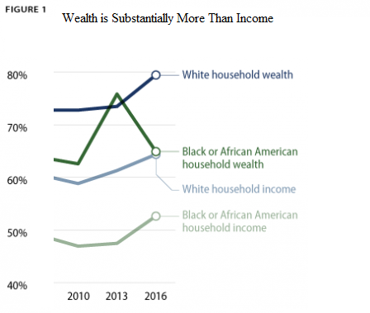

Source: Hanks, Angela, et al.“Systematic Inequality.”: How America's Structural Racism Helped Create the Black-White Wealth Gap.”Center for American Progress, 21 Feb. 2018 ,www.americanprogress.org/issues/race/reports/2018/02/21/447051/systematic-inequality/. Accessed 3 Jun. 2021.

The first figure shoes that wealth measures by race counting the share of household with no or negative wealth. The normal Black wealth was 11 percent that of Whites, and somewhat more than one-quarter of Blacks had no or negative wealth, compared with less than 10 percent of Whites. The Black-White wealth gap has persisted for decades. A simple calculation in the original document puts the persistent and policy-driven Black-White wealth gap into perspective. Consider that the racial wealth gap measured as the ratio of median Black wealth to median White wealth slightly narrowed from 2013 to 2016, so the question is how bad is the wealth gap between Blacks and Whites? (Hanks et al.).
According to 2016 Federal Reserve data highlighted in the previous chart
Black households have fewer issues and are in a need of private savings than their White counterparts. For a range of reasons, Black people face a lot of negative financial gain shocks. Moreover, they are less probably to own access to emergency savings. Consequently, Blacks are exposed to fall behind on their bills and go in debt throughout time (Hanks et al.).
To sum up, the research shows that African-American households have significantly lower household income than White households. When it comes to examining wealth, the numbers are even more disastrous. The chart above examines the poverty rates until 2019.
Figure 2. Poverty Rate by Race and Hispanic Origin 2010 to 2020
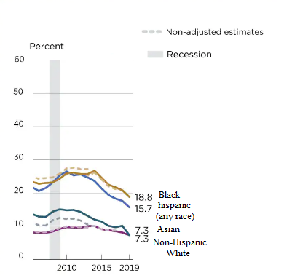
Source: Creamer, John. “Inequalities Persist Despite Decline in Poverty For All Major Race and Hispanic Origin Groups.” Census,15 Sep,2020. www .census .gov /library /stories/ 2020 /09/poverty-rates-for-blacks-and-hispanics-reached-historic-lows-in 2019. Accessed 14 May 2021.

In 2019, the poverty rate for the United States was 10.5%, poverty rates declined between 2018 and 2019 for all major races. Blacks and Hispanics reached historic lows in their poverty rates in 2019. The Poverty rate for Blacks was 18.8%; for Hispanics, it was 15.7%.The figure shows that for Blacks, the poverty rate of 18.8% in 2019 was the lowest rate observed since poverty estimates were first produced for this group from 2010. The previous low for this group was 20.8% in 2018.Poverty rates in 2019 were also the lowest ever observed for Hispanics (15.7%), compared to the prior low of 17.6% in 2018. The 2019 poverty rate of 7.3% for non-Hispanic Whites was not statistically different than the previous low (historically adjusted) of 7.2% in 2000 (Creamer).
The previous analysis shows that poverty among African-Americans appears to decrease over the years. Unfortunately, they are still more likely to live in poverty and hunger .So, the wealth division between African Americans and Whites is way too unequal to the benefit of Whites. Racial discrimination mainly leads to less chance for financial stability, which provides the basic needs of life.
2.2 Employment of African Americans in the United States
Millions of African Americans live in low-income neighborhoods with limited access to excellent employment and schools, as well as high crime rates. They are nearly twice as likely as Whites to be unemployed are. Black students trail behind their White peers in educational attainment and accomplishment. African American communities have higher than normal crime rates, which is a recurring issue. Jobs are important to improve Black’s communities and decreased unemployment would help them to lift themselves out of poverty (Algernon).
2.2.1 African American Face Systematic Obstacles to Getting Good Jobs
African Americans continue to confront higher unemployment rates, fewer job prospects, lower income, less benefits, and more job insecurity. They are more likely to work in jobs with less stability than Whites. For example, when the economy fails, African American employees' unemployment rates rise faster than White workers', a phenomenon known as “last hired, first fired”. Moreover, unemployed Black workers take a longer period to find and secure a new job than White workers do (Weller).
African Americans have historically had a worse labor market experience than Whites, and this practice persists today. There have been and continue to be various variables that have contributed to this. The riots that destroyed Black business owners' wealth on Tulsa's Black Wall Street in 1921, codified segregation, legal racial terrorism during the nearly century-long period from Reconstruction to the Civil Rights era, systematic exclusions of African Americans from better-paying jobs, and continued occupational segregation (Weller).
To close these persistent labor market gaps, African American families need more wealth to begin with, which would make it easier for families to invest in their own futures. It might be used to fund both children's and parents' education, to establish a business, or to purchase a home in a good-paying neighborhood. And even to move to new places when better opportunities arise. Each of these benefits provides families with more and better jobs. Starting a business gives people more control over their own lives and thus the potential to avoid the uncertainty that can come from working for someone else in a low-paying job with irregular hours. People with a college degree typically have lower unemployment rates and greater access to well-paying jobs with decent benefits (Weller).
2.2.2 Black Workers Have Higher Unemployment Rates than Whites
African Americans have continuously higher unemployment rates than Whites. There are several possible explanations for this. Blacks are less likely to attend and complete college, and they face higher financial challenges in obtaining a college education, ending up with more debt than White graduates do and pay more for their loans. Even among college graduates, African Americans have a higher rate of job insecurity and employment rate has been declining for a decade, increasing the labor market prospects for many groups along the way (Weller).
Moreover, even in a good labor market, the trend toward decreasing unemployment rates should not conceal the fact that African Americans have greater unemployment rates than Whites. Even when looking at subpopulations, the unemployment rate for Black workers remains greater than that of Whites. The data further shows that African Americans, regardless of age, gender, education, or veteran status, have greater unemployment rates than Whites.
Figure 3. Different Unemployment Rates over Multiple Categories.
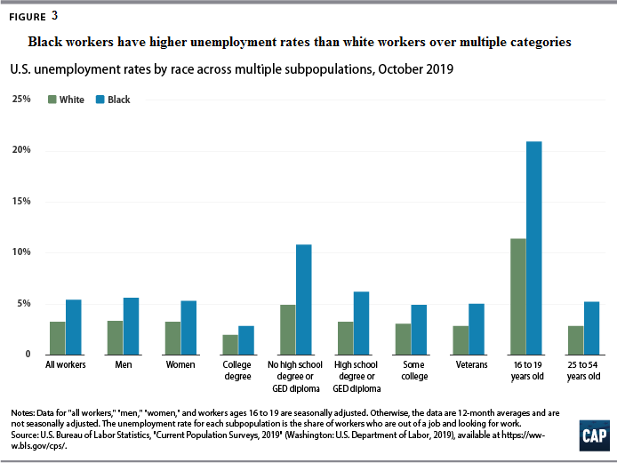Source: Weller, E. Christian.“African Americans Face Systematic Obstacles to Getting Good Jobs.” Census,5 Dec. 2019,www.americanprogress.org/issues/economy/reports/2019/12/05 /478150/african- americans-face-systematic-obstacles-getting-good-jobs/. Accessed 14 May 2021.
Regardless of educational achievement, Black workers have a higher rate of unemployment than their White college-educated counterparts. For example, the Black unemployment rate among college graduates averaged 2.8 percent from November 2018 to October 2019, which was 40 percent higher than the White unemployment rate of 2 percent during the same time period. (See Figure 3).While possessing a college diploma provides access to better-paying, stable employment with better outcomes for all workers; the benefits are not distributed equally. Black workers, regardless of their level of education, continue to encounter challenges in the labor market such as employment discrimination, occupational segregation, and unequal pay.
2.2.3 Black Workers Have less Access to Jobs than Whites
Both prime-age Black and White workers were employed at lower rates than in the late 1990s, implying that the labor market is not as strong as the unemployment figure suggests. In comparison to White workers, Black workers experience more challenges in finding jobs and fewer job opportunities make it harder for people to save for their futures.
Figure 4.White Workers Have More Employment Opportunities than Black Workers
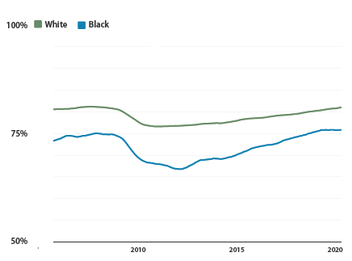
Source:Weller, E. Christian.“African Americans Face Systematic Obstacles to Getting Good Jobs.” Census,5 Dec,2019,www.americanprogress.org/issues/economy/reports /2019 /12 /05/ 478150/african- americans-face-systematic-obstacles-getting-good-jobs/.Accessed 14 May 2021.

Furthermore, there remains a persisting wealth gap. From November 2018 to October 2019, 75.7 percent of prime-age Black employees were employed, compared to 80.8 percent for White workers in the same age range. Even after a decade of labor market gains, Black employees face greater barriers to employment than White. People are having a harder time saving for the future since there are fewer career prospects.

2.2.4 The Opportunities of Well-Paying, Stable Jobs with Decent Benefits to Black Workers

Discrimination, salary inequality, and occupational steering are all visible markers of employment quality, not just measurements of job availability for African Americans in the labor market. For example, Black workers are paid far less than White workers are. From July to September 2019, the average weekly earnings for Black full-time employees were $727, compared to $943 for Whites (See Figure 5).When men and women's incomes are compared by race and age, it is clear that wage disparities persist even among full-time workers, implying that massive gaps in economic security exist even when the labor market is solid. Lower salaries for Black workers lead to fewer savings since families have less money after paying their bills.

Figure 5.The Earn of Black Workers across Subpopulations
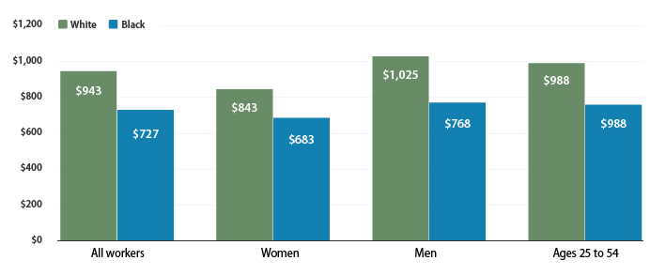
Source:Weller, E. Christian.“African Americans Face Systematic Obstacles to Getting Good Jobs.” Census,5 Dec,2019,www.americanprogress.org/issues/economy/reports /2019/12/05 /478150/african- americans-face-systematic-obstacles-getting-good-jobs/. Accessed 14 May 2021.
African Americans also receive fewer benefits from their employers than White workers. In 2018, only 55.4 percent of Blacks had private health insurance, compared to 74.8 percent of Whites. According to Craig Copeland of the Employee Benefits Research Institute, among full-time, year-round workers, African Americans are 14 percent less likely than White workers to have any sort of retirement plan via their company. They find it more difficult to save since they have fewer occupational advantages and receive less assistance in planning for retirement than their White colleagues (Weller).
African Americans not only work for less pay and with less benefits, but they also work in less stable occupations and industries, such as retail and parts of the health-care industry, like home health aides and nursing home workers.
Besides, as stated below, African Americans are more affected by recessions than Whites, and they are out of work for longer than other unemployed workers. Black’s employment fluctuates more than it does for Whites. From 75 percent shortly before the Great Recession began in September 2007, to a low of 66.7 percent in October 2011, the employed share of prime-age African American workers decreased by 8.3 percentage points (See Fig 5). In July 2010, the proportion of White workers declined by only 4.5 percentage points, to 76.5 percent (Weller).
The drop in prime-age employment rates related with the Great Recession began two months earlier for African Americans than for Whites, and lasted 15 months longer for African Americans than for Whites (See Figure 5).Unemployed African American workers look longer for a new job than Whites do. Unemployment for Black workers was 25.5 weeks on average from September 2018 to September 2019, compared to 20.8 weeks for White workers (Weller).

Figure 6.The Time Spent Looking for Jobs between Blacks and Whites
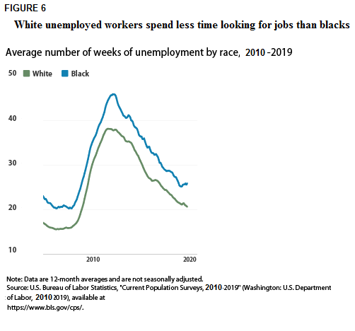Source:Weller, E. Christian E.“African Americans Face Systematic Obstacles to Getting Good Jobs.” Census,5 Dec. 2019,www.americanprogress.org/issues/economy /reports /2019/12/05/478150/african- americans-face-systematic-obstacles-getting-good-jobs/. Accessed 14 May 2021.

2.2.5 The Racial Wealth Divide is Widening
Wealth is required by African American families in order to increase access to decent work prospects. For example, wealth increases the likelihood of people being able to secure education frees for themselves and their children, as well as being able to move to areas with more and better jobs. African American families have significantly less wealth than White families, and the disparity has only grown in recent years. On average, Black families today own around one-fifth of the entire wealth possessed by Whites, including the imputed worth of defined benefit pensions. Just before the Great Recession, this gap had shrunk to one-fourth. (See Figure 7). However, African American families lost more wealth during and after the financial and economic crisis .The latter led to widening racial wealth gap over the past decade (Weller).

Figure 7. The Racial Wealth Gap since the Great Recession
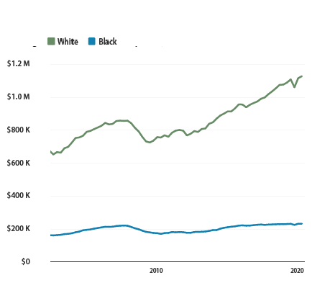
Source:Weller, E. Christian.“African Americans Face Systematic Obstacles to Getting Good Jobs.” Census,5 Dec,2019,www.americanprogress.org/issues/economy/reports /2019 /12/ 05/ 478150/african- americans-face-systematic-obstacles-getting-good-jobs/. Accessed 14 May 2021.

To eliminate the institutionalized barriers that prevent African Americans from building wealth, a number of elements will have to come together. A long period of labor market expansion is a good start, but it is not enough, as the most recent figures reveal. Although, increased hiring has reduced unemployment and increased job chances, African Americans are more likely to be unemployed, have fewer job chances, earn less, receive fewer employer-sponsored benefits, and work in less stable occupations. All of these factors contribute to the already widening racial wealth gap (Weller).
However, the labor market in the United States has been expanding for nearly a decade, with employees of all races benefiting. African Americans continue to have a higher unemployment rate and fewer opportunities for decent jobs than Whites. These systematically different labor market experiences intensify African Americans' needs for more wealth while also making it more difficult to achieve that wealth in the first place. To ensure that Black employees have the same access to good jobs as White workers, new and innovative techniques to closing the racial wealth gap are required, as well as the labor market reforms (Weller).
2.3 African American Education in the United States
As African Americans gained numerous rights they also gained opportunities to learn, but they faced significant challenges to live with several segregated laws, such as the separated education that had a deep influence on Blacks career .Also the different living conditions between Black and White students during their school years which led them to face a lower chances of having a good education ,there are multiple problems with American education, as are the stark disparities between White and Black students. In schools, there are a range of educational strategies and procedures used.
2.3.1 Blacks and Whites: Still Separate, Still Unequal
In 1954, the United States Supreme Court ruled that segregated schools were unconstitutional. School discrimination based on race is a relic of an ancient period and a part of America's racist legacy that seems to have occurred a long time ago. American education is riddled with flaws and issues along with the stark disparities between White and Black students. When schools use various instructional strategies or procedures, they may have an impact on how particular students learn and what kind of learning outcomes they achieve though racial segregation in public education in the United States has been illegal for 65 years. Nonetheless, American public schools remain overwhelmingly segregated and unequal, with serious repercussions for children, especially students of color (Meatto). Besides, Black children are suspended at a disproportionately high pace in colleges. Experts say that they often face harsher punishments for the same actions as their White peers. According to a study of the African American Policy Forum and Columbia Law School's Center for Intersectionality and Social Policy Studies, they are almost six times more likely to receive out-of-school detention. According to the report, furthermore, among students who are boys, Black, weak, and have a disability, are assumed to raise the risk of exclusionary discipline (Cook).
The living conditions in which Black and White children are raised during their school years are not the same. Black children are much more likely to live in low-income families, receiving long-term social assistance, poor , compared to the White and Hispanic children who live in a family with at least one member with a secure job. They face a lot of problems such as grade retention, obesity, unsafe sexual activity, increased risk of injury, and increased risk of interpersonal or self-directed abuse, unfortunately, the list is endless and the issues continue through adulthood (Cook).
According to Gregory and Weinstein, Black students are most likely to be suspended for merely defiant acts, while other races face fewer corrective discipline for similar offenses Therefore, Black students are suspended at a disproportionately high pace in schools. Experts say that Black females, for instance, often face harsher punishments for the same actions as their White peers. According to a study by the African American Policy Forum and Columbia Law School's Center for Intersectionality and Social Policy Studies, they are almost six times more likely to receive out-of-school detention.
2.3.2 Understanding the Racial Discipline Gap in Schools
Black students suffer from the effects of the omission.Taking into account behavior problems, teachers’ race, and other classroom influences. Moreover, the study of Bradshaw has revealed that Black and Hispanic students, especially boys, are punished at a higher rate than White students (Bradshaw et al.). During Obama’s era some change was achieved. It had been proven that the more he succeeds against all odds, the higher Black students perform, even though the stereotype challenge distortion is present. President Obama has shown that a Black person can find achievement in any field and that a person of color can break down barriers. Moreover, Education is the primary passport to personal growth and social mobility for African Americans (Hout).
“Blacks are more optimistic about the American Dream after Obama’s election to the White House despite their worsening economic outlook” (Stout and Le) he was an example for African American children that can influence how they perceive themselves and their expectations for success in life. He gave them hope.
President Donald Trump signed a landmark bill on Thursday, 19 December 2019 that would send more than $250 million per year in perpetuity to the nation's historically Black colleges and universities, as well as scores of other schools that represent vast numbers of minority students. In signing the bill, Trump said historically Black schools have “never had better champions in the White House (Binkley).
Figure 8. Percentage of Public Elementary and Secondary School Students, Race/Ethnicity.
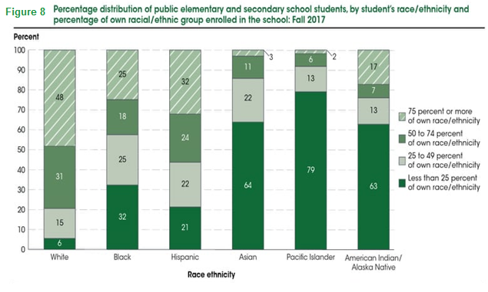
Source:“Racial Ethnic Enrollment in Public Schools.” National Center For Education Statistics, May 2020,https://nces.ed.gov/programs/coe/indicator_cge.asp#:~:text=In%20fall%202017%2C%20of%20the,million%20were%20American%20Indian%2FAlaska. Accessed 5 May 2021.

Examining attendance statistics for specific racial/ethnic populations provide accurate information about school enrollment trends. These statistics indicate how many students attend public schools with classmates the same racial/ethnic group. In the fall of 2017, about 48 percent of White students were enrolled in public schools that were mostly made up of students of their own race. (i.e., 75 percent or more of enrollment was White), while about 6 percent of White students were enrolled in schools with less than a quarter of White students. Around 25% of Black students were enrolled in Black public schools, and 32% of Black students were enrolled in schools that were predominantly White. 32 percent of Hispanic students were enrolled in public schools and American Indian/Alaska Native (17 percent) was enrolled in public schools (“Racial”).
Overall, African Americans in the United States have suffered centuries of discrimination in all its facets, the unequal social opportunities between Whites and Blacks remain today. As the racial wealth gap continues to grow between both races, African Americans yet have less access to stable well-paying jobs with decent benefits, they still face persistently higher unemployment and lower chances of a good education. As a result, this discrimination is the reason of high crime rates and the relationship between race and crime has been a source of public and intellectual debate. The rates of crime differ significantly by racial group and this problematic will be more detailed in the chapter bellow which is going to investigate the over representation of Blacks in the American prisons and its relationship if any with police practices and training.

Chapter Three
Ethnic Disparity in State Prisons with Color-Blind Police Practices
Police violence against Blacks has contributed, over the last few years, to explosive growth in the prison population in the United States and in growing race prejudice. Such aggressive practices have soared Black imprisonment rates. In this chapter, the reasons for the considerable rise in the number of Blacks in the American prisons are to be highlighted by placing attention to police practices and training that could well be behind the over representation of colored people in the United States’s state and federal prisons.
3.1 The Roots of Racial Bias to the Over Representation of Black in Prisons
Barack Obama once said, «The United States is home to 5% of the world’s population but 25% of the world’s prisoners. Think about that!” (New) . According to Ashley Nellis who has an academic and professional background in analyzing criminal justice policies and practices “African Americans are imprisoned at 5.1 times that of the White imprisonment rates in state prisons. The rates in five states are higher than 10-1 (Iowa, Minnesota, New Jersey, Vermont, and Wisconsin). And over half of the prisoners in 12 states are Black in Alabama, Delaware, Georgia, Illinois, Louisiana, Maryland, Michigan, Mississippi, North Carolina, New Jersey, South Carolina, Virginia. Maryland, however, tops the list nationwide with an African American population of 72%”.
Figure9.Sentenced Prisoners by Race 2010-2019

Source: Bureau of Justice Statistics, Federal Justice Statistics Program, 2019 (preliminary); National Corrections Reporting Program, 2018; National Prisoner Statistics, 2009-2019; Survey of Inmates in State and Federal Correctional Facilities, 2004; and Survey of Prison Inmates, 2016.Accessed 6 May 2021.

As illustrated in Figure 9, which represents the number of American prisoners by race. The first red curve for the Black prisoners shows a noticeable increase year in year out comparing with the other races (Whites bleu curve and Hispanic green).On the other side, it clearly indicates that from the year end 2014 to the year end 2019 the number of prisoners of the three races declined. As a result, the number of Black prisoners 2010 to 2019 was higher than the other races because of multiple reasons such as unemployment, the social status and education.
The job opportunities for much first time and repeated offenders, particularly Blacks, were significantly affected by mass incarceration. There are various interpretations of the relationship between the unemployment rate and growth of Blacks representation in prisons. The research of Bruce Western indicates that people of poorer economic conditions will most likely become criminals as a way to get what they want in life. This decision leads to a life disruption that will most probably lead to imprisonment. Furthermore, the Western analysis found that disadvantaged Black males in criminal justice are slightly more likely to receive poorer pay. The stigma attached to those who were detained for offenses most probably explains this. Employers are particularly reluctant to employ individuals with a history of crimes. Thus, a person with a criminal record is less likely than a person with no criminal record to be employed. This is significant because it further reduces the chances for former criminals to go back into the jail system and to continue their 'life path'. Additionally, when ex-offenders return to the same neighbourhood they came from, which can be an issue if employment opportunities are already limited. Besides, the majority of prisoners are under-qualified Black males, which is clearly reflected in pay gaps and unemployment rates (Esparza Flores).
Incarcerations mostly affect the disparity between Whites and Blacks in term of wages inequalities. In other reports; such as Western and Pettit's one, it is argued that most of Blacks go back to jail because they are mostly uneducated, unqualified, and with no assistance from family members. Incarcerations, therefore, break down the skills of certain people, in addition to the fact that the time spent in prison takes away time from employment and acquisition of labor skills from work and knowledge from training, consequently to the inability of prisoners to continue using their skills when locked down. Moreover, most employers are less likely to invest in unskilled workers with criminal records. Therefore, ex-offenders are linked to low-wage employment and the salaries they get and the probability of imprisonment and recurrence play an important part in educating prisoners (Esparza Flores).
The Environmental circumstances in the Black neighbourhoodhave affected the actions of the residents and the social organization of communities, particularly the poor, has a profound effect on that particular area on the level of crime and the risk of recurrence. According to a report by Kubrin and Stewart, after prisoners are released in their neighbourhoods, they start looking for opportunities in their community to integrate effectively into society; but, if this is not available, they will be considerably more likely to return to the criminal justice system especially if people of the community have high crime, violence, and social problems. Studies from Harris found that Blacks in these neighbourhoods are more likely to be imprisoned compared to Whites. Moreover, when Blacks and Whites are in the criminal justice system, social-economic inequalities make it more difficult for Blacks to access the resources (Esparza Flores).
Grade in school also is a good indicator on whether an individual is going to enter the criminal justice system or not. The majority of those who enter jail are Black high school drop-outs or have little to no college education. Besides, people with low qualifications are also more likely to be involved in violence. The work and intellectual qualifications are not at the standard that most employers want, and so the job opportunities available to them are greatly reduced. However, when it comes to race, uneducated young Black men are eight times more likely to go to prison than their White counterparts are (Esparza Flores).
3.2 Police Violence and Black People
The United States’ police brutality is the unjustified or unreasonable and sometimes unconstitutional use of force by policemen against civilians in general and Blacks in particular. Police violence includes abuse (for example, beatings, torture, and murders). Additionally, some more common concepts of police brutality such as; harassment (as well as false arrest), bullying, and verbal violence may also cover some forms of assaults. Notwithstanding the vast majority of victims that are exposed to police violence, African American secured the lion’s share. In the estimation of most experts, a key factor explaining a central reason reflecting the predominance of African Americans among victims of police brutality isanti-black bigotry among representatives of predominantly White police forces. In police violence against other traditionally poor or disadvantaged communities, certain biases are believed to play a part (Moore).
Racism is seen by African Americans and other minority groups as being a big source of police violence. It is far from being the only other considerations related to the peculiar institutional ethos of the municipal police services, which emphasizes community unity, commitment, and an attitude of "strength demonstration" to any threat encountered by a policeman. The recognition, performance, and advancement of rookie officers in the force depends on following the group's views, beliefs, and behavior that have traditionally been infused with prejudices against Blacks. Because African Americans were the primary – but not the only – subject of police violence in the United States, the rest of the chapter will deal with their experiences with police brutality (Moore).
Pressure on police services and legislatures, especially in the United States, has been imposed by protests scattered around the globe by reforming legal compliance procedures through eliminating police violenceor even the dissolution of the police forces. As scientists are encouraged by the pace of change, some are concerned about the chances of failure without sufficient evidence to support new policies. For several years, researchers such as Justin Nix have argued that more detail on disproportionate police force used in the United States is necessary and for specific research to assess measures such as instructions on how stressful situations should be deescalated, or on how officers use body-worn cameras to better clarify the prevalence and the risks caused by police brutality. Federal Departments, investigative academics and newspapers at the time conducted data collection campaigns. There have been some disturbing results from these growing data sets. In the United States, law enforcement officials kill almost 1,000 people per year. On one basis, the likelihood of Black men being killed by police is 2.5 times higher than White men. A study conducted by Justin Nix an associate professor in the school of criminology and criminal justice at university of Nebraska Omaha showed that Black people who were shot dead by officers were twice as likely to be unarmed compared to White people. “We have enough evidence that tells us that action needs to be taken,” says Justin Nix, a criminologist at the University of Nebraska Omaha. “One thousand deaths a year does not have to be normal” (Peeples).
Figure 10. Policing Force in Answering 911 Calls
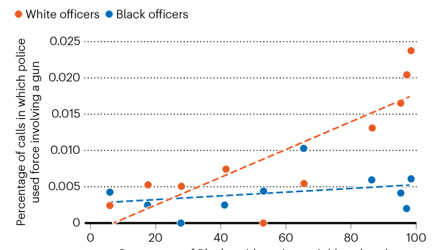

Source. Hoekstra, M. & Sloan, C. W. National Bureau of Economic Research Working Paper
26774 (2020). Accessed 5 May 2021.

The economist Mark Hoekstra of Texas A&M University gathered data on the scale and nature of bias in the United States Police Department and its abuse by reviewing and gathering 911 calls. After receiving almost two million 911 calls in all the United States based on its data, the researcher found that White policemen might use guns 5 times in the Black neighbourhood than Black policemen in the same place (Peeples).
It is noticeable on Figure 10, which represents the percentage of the emergency calls in which police used force involving a gun according to the percentage of Black residents in neighbourhood. The first red line for the White officers is showing a noticeable increase. On the other side, we can notice that the blue line, Black officers, shows a very slight increase. As a result, we conclude that the use of a gun by officers increases with the increase in the population of the community, especially by the White officers.
3.3 Racial Color – Blind Issues in American Police Training and Practices
Following series of crimes and deaths, police misconduct and the abusive use of force have been increasingly scrutinized and brought to the fore. Most researchers criticized police training and practices toward Blacks. By carrying out detailed investigations on their racial and training techniques.
3.3.1 A Probe into Police Practices
The American writer Ijeoma Oluo said;“Our police force was not created to serve Black Americans; it was created to police Black Americans and serve White Americans.” (McLeod).Jennifer Eberhardt, Stanford social psychologist, has cooperated with police officers across the country to help them recognize implicit bias and acknowledge racial disparities in the police force. Jennifer's experience with the Oakland Police Department resulted in 50 findings for how police authorities might build stronger relationships with their communities. The collaboration of Eberhardt with the Oakland Police Department emphasizes the importance of statistics and public transparency in the identification and development of evidence-based solutions by police departments (“Stanford”).
The study contains 50 concrete guidance to police departments, including a more extensive collection of information and more focused attempts to shift the dynamics of law enforcement mentalities, practices, and systems contributing to ethnic inequalities. Among the results of the studies is that the probability that Black Americans were checked during a stopover was four times compared to White seven if they were not convicted, they were much more likely to be handcuffed. The study states that police departments across the United States are motivated by a commitment to serve communities with fairness, dignity, and pride. However, tensions between the police and colored groups happens to be at an all- high(“Stanford”).
For over a decade, the high deaths rate of Blacks by police officers, which are involved in criminal brutality, the Oakland Police Department has been subject to federal oversight. Psychologist Jennifer Eberhardt's Stanford researchers have been committed to helping Oakland comply with the federal law and order for the collection and analysis of traffic stop data by race. Oakland police started wearing body cameras in 2010. This study analyzed traffic stop data from police body cameras for 5 years during this period, 28,119 traffic and pedestrian stops were recorded by 510 police officers. Police may legally stop persons based on infringement offenses including any driving offenses a common reason, and reasonable suspicion or for probating or communicating form, among other purposes, more than 157000 terms including the language and tones used during a traffic stop with citizens were thoroughly investigated in audio recordings for one month. They tracked the words of respect or anxiety and how the interaction happened when the citizens experienced this situation (“Stanford”).
More than 1,000 incident accounts or "stories" were also analyzed and over 400 residents of Oakland reviewed their views on police-community issues. They found that Black people comprise 60 percent of the Oakland police arrests or about 17,000 stops. This average is three times higher than the second largest population of Hispanics (Whites accounted for 13 percent). The investigation has already shown that if officers can detect the race when they search, it is more likely that the stopped individual will be Black (62%) than when officers cannot determine the race (48%). Also, in a stop, 1 out of 4 times, Blacks were more likely to be handcuffed than Whites, 1 out of 15 times, except arrests that are most likely to be screened. But officers are not likely to be saved from such investigations (1 in 5 vs 1 in 20 times for White), and after a police search, Blacks are more likely to be detained, 1 White men in every 6 vs. 1 in 14. Furthermore, 77% of police officers from Oakland who made stops during 13 months never looked for a White person discretionarily, but 65% of them looked for Blacks. Similarly, 74% of these officers did not handcuff a White male who had not been detained at the end, but 72% did so for an African American. Eberhardt said; “Differences exist in how police officers treated African Americans compared to those of other ethnic groups.”(“Stanford”).
The views of the policemen are also reflected by the media. Here is an overview of studies made by Pew Research Center in recent years on the crossroads between race and law enforcement. Most Black and White Americans, both, say that Black people in the police and in the criminal justice system as a whole are viewed less equitably than Whites. 84% of Black adults say that the Black is usually treated less equally than Whites, in the 2019 Center survey, and 63% of Whites say the same things. Likewise, 61% of White voters think that Blacks are treated less equally than Whites are in the United States criminal justice system compared to 87% of Blacks (Standford).
Figure 11.Blacks and Whites Interactions with Police Officers
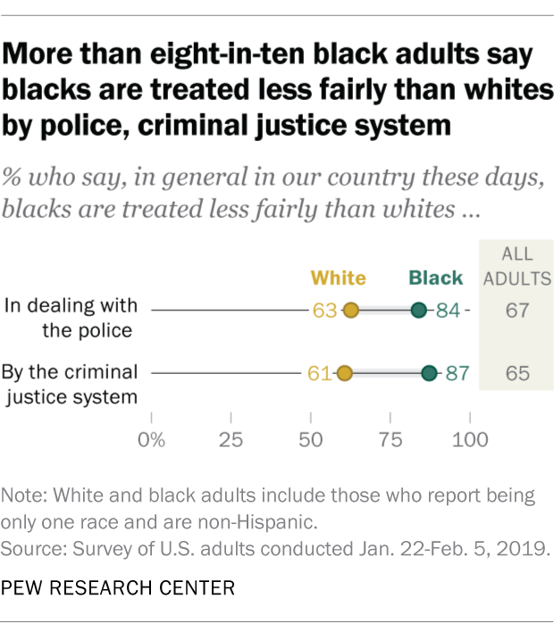
Source:“More than Eight-in-Ten Black Adults Say Blacks Are Treated Less Fairly than Whites by Police, Criminal Justice System.” Pew Research Center, 4 Jun. 2020, www.pewresearch.org/fact-tank/2019/05/21/from-police-to-parole-black-and-white-americans-differ-widely-in-their-views-of-criminal-justice-system/ft_19-05-16_racecriminaljustice.Accessed 10 May. 2021.

In addition to that, according to the same survey, Black adults were about five times as likely as Whites, to say they were disproportionately harassed by police based on their race or ethnicity (44% versus 9%).59% of Black men said that they were stopped unfairly compared with 31% of Black women.
Table1. Black Americans Experiences of Racial Discrimination
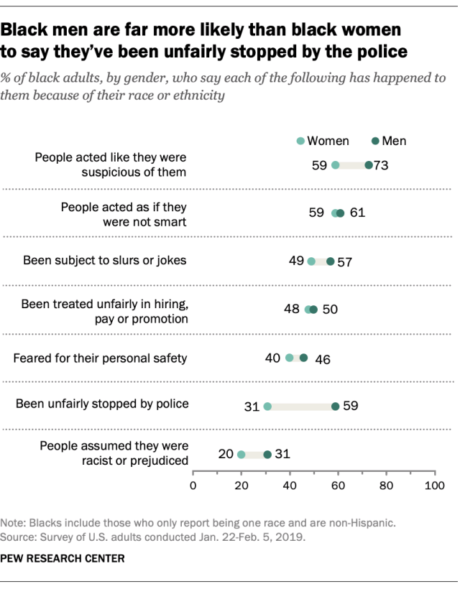
Source.“More than Eight-in-Ten Black Adults Say Blacks Are Treated Less Fairly than Whites by Police, Criminal Justice System.” Pew Research Center, 4 Jun. 2020, www.pewresearch.org/fact-tank/2019/05/21/from-police-to-parole-black-and-white-americans-differ-widely-in-their-views-of-criminal-justice-system/ft_19-05-16_racecriminaljustice. Accessed 10 May 2021.

The latest murder of an African American, George Floyd, while the event revealed the structural traces of racism that still exist; it also exposed the dehumanization of Black peoples by the United States, which ironically advocates rights and justice is the world's most vigorous promoter. Mass prison numbers in the United States show that marginalized populations are over-represented, and it is startling that 1 out of 35 African Americans are behind bars (“Overview”).
No casualty, in the courts and prison systems, people of color are brutalized and the capital of the state is imprisoned. The calling of the United States prison system as an ethnic-racial ghetto is no exaggeration because there are more African Americans in prison nowadays than at college. The current prison policy reflects a long-standing legacy of segregation that has threatened the country's social and moral structure. In the hands of thesystem of justice, marginalized communities seem to struggle paradoxically. Therefore, transformative reform is needed immediately via protests like Black Lives Matter. (“Overview”)
African Americans are continually subjugated as problematical' people by discriminatory laws and stereotypes, which are the first casualties of mass incarceration programs. Since the Civil War had put an end to slavery in the United States, the current penal system has become an institution of forced labor consisting of people of color (“Overview”).
3.3.2 Exploring Police Training
Dr.Benjamin Spock said; “Most middle-class Whites have no idea what it feels like to be subjected to police who are routinely suspicious, rude, belligerent, and brutal.” When the United States law enforcement authorities were accused of racist police, implicit racism training was one of the most frequent responses for the authorities. The training consists normally of a lecture in psychological theory, where people will make dangerous snap decisions through implicit stereotypes. For example, unconscious organizations of African American criminals can make cops more suspicious. After many protests, the States rushed to demand further training for its police force personnel. However, amid the boom in unconscious bias instruction, no real-world study was undertaken as to whether it is really changing what police officers do on the job. "It's like I'm offering you a pill to fix some disease, and I haven't tested to see whether it actually works," says Joshua Correll, an associate professor of psychology at the University of Colorado Boulder, where he studies racial bias. He also added "Expecting that we can take people in and train them to reduce their implicit bias, I don't think it's been supported by the literature"(Kaste).
The new study at the New York Police Department allowed researchers to track the effects of mandatory implicit bias training as it was implemented in 2018.

Figure 12.Officers Behaviours about Implicit Bias Training
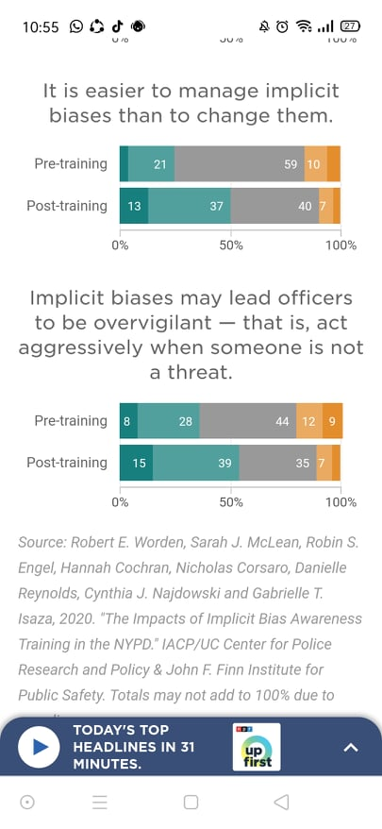
Source.Worden, E.Robert, et al. "The Impacts of Implicit Bias Awareness Training in the NYPD." IACP/UC Center for Police Research and Policy,FINN, Jul. 2020.

In the conducted survey about police attitudes before and after their training, which raised awareness among the police officers and created a desire to apply the concepts in the training . In addition to that, Robert E. Worden, director of the John F. Finn Institute for Public Safety in Albany, N.Y., and the lead author of the study declared that "We could certainly say that the training can be credited with elevating officers' comprehension of what implicit bias is," (Kaste), However, the researchers analyzed evidence on the work behavior of NYPD officers before and post-training. In particular, they examined the disintegration of the racial inequalities in the population detained and interacted with these officers and they saw no significant difference in those numbers (Kaste)
Table 2.Police Force Actions towards Black People
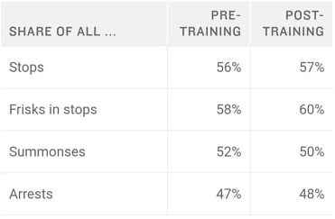

Source. Worden, E.Robert , et al. "The Impacts of Implicit Bias Awareness Training in the NYPD." IACP/UC Center for Police Research and Policy,FINN, Jul. 2020.

As it is shown on the table above, the influence of police training was between 1% and 2%.it is assumed that the effect of implicit bias training conduct on police is very low. "It’s fair to say that we could not detect effects of the training on officers' enforcement behaviors," says Worden and he call it a "null result": It does not prove implicit bias training changes cops' behavior, but it doesn't disprove it either (Kaste).
Many scholars like Lorie Fridell Adam Plantinga and Joshua Corell declared different points of view about the training result such as; professor Lorie says that" We believe that our training reduces biased behavior on the streets of the jurisdictions where we train" that the survey does not say that the investigation had not detected improvements in behavioral results while Adam Plantinga, a San Francisco police sergeant who writes about policing says "I think that even the most cynical cop out there would agree that prejudice on the street is a problem and you've got to try to do something,". In other words, Plantinga claims that the curriculum of his department was "very successful" because it helped officers discover implicit connections that could influence their second-part decisions (Kaste).
Moving to professor Corell, he said that "You don't need to intervene at the level of the individual [police officer's] brain you need to intervene at the level of the culture," Paying attention that the real problemis not in the brain of officers or acts but in the culture itself,. Even one of the pioneers of the theory of implicit bias, Harvard University psychology professor Mahzarin Banaji, had worries about the quality of implicit bias training for the police she said "to me, is like saying, 'Can I give you a lecture on climate change?' and tomorrow you're going to stop driving your car and start taking public transportation". She believes that even the best implicit bias training should not produce immediate improvements in officer’s behavior, even though years of study are yet to come before researchers can tell how to deal effectively with implicit bias. Lois James added, "This doesn't mean we should eradicate implicit bias training. It just means we have to work harder"(Kaste).
To conclude, Racism is an issue that impacts the lives of many Americans, both individually, institutionally, and socially. Despite the American propaganda that has spread profusely since the beginning of the last century, that the United States is a "land of dreams and freedoms", that is, it is a haven for all ethnic and races, this was not the case for Black Americans, who were not equal with White Americans in most walks of life. in light of the United States voice in human rights violation, arrest and racism forum, the numbers reveal a clear imbalance in the country of freedom and the bitter reality of its prisons that shows the over-representation of Blacks in American prisons compared to Whites. Despite the appointment of Barack Obama, the first Black president of the United States, his presidency saw many anti-black riots, in addition to many crimes committed by police officers.
After the reality of the police excessive use of force The results of the surveys show that police brutality is a matter of a big influence to the African-American community because it addresses many different situations, including traffic stop-shooting and 911 calls, in which the majority of researchers work hard to train police to prevent the propagation of this issue and all efforts investigating the on-going crimes against Blacks by shedding light on police misuse of weapons.

Conclusion
The history of America has seen various events that have constructed, organized, and transformed society with its inhabitant’s beliefs. America is believed to be a country of immigrants, made of many several ethnic groups, among them there are African Americans, who have played an outstanding role in America's history and provided the example of a common minority that is fighting for its freedom and rights. They were among the races which were transported from Africa into the American continent through slave trade who were kidnapped away from their homes, friends, and families. Slaves were forced to work under terrible conditions and received no pay. They used to work long hours –often without taking rest but deep inside they believed in their rights as humans and their skin color has nothing to do with their characters, intelligence, and abilities.
The appearance of slaves in American states was among the reasons for creating the bloodiest war in American history between the North and the South. During the American Civil War, almost four million slaves were laboring in the United States, with almost all of them in the Southern states. The extension of slavery to the West was the principal political issue preceding the outbreak of the Civil War. Northern abolitionists felt that if they could stop the growth of slavery, they would be able to abolish it completely. After Abraham Lincoln was elected president in 1860, the Southern states seceded from the Union, founding the Confederacy. The Confederate States of America were dedicated to the maintenance of slavery, whereas the Northern Union was dedicated to the preservation of the country as well as the abolition of slavery. Consequently, the issue of slavery in America helped in the creation of The American Civil Rights Movement that was a movement in the South against racial segregation and injustice. It arose from the centuries-long attempts of enslaved Africans to combat ethnic injustice and eliminate slavery.
By stroking a pen, President Lincoln ended the conflict by declaring the Emancipation Proclamation of changing from slavery to freedom of all the enslaved Americans. This meant that even though the slaves worked across the whole South, they would be legally free if they could reach the North. In 1865, the Union won control of the Confederate States, and the slaves were legally liberated all over America and many of the liberated slaves joined the United States Army and the Navy in ensuring their free status. Slavery had formally ended as a result of the Civil War, but it did not bring an end to segregation against Black people.
Besides all of the several attempts of the government, America still faces a color line dilemma. Black Americans' position in American society did not immediately improve, they rather faced another battle for racial equality, the one that is still ongoing in the United States. Furthermore, many historians, sociologists, and researchers focused on the significant role of Blacks in American society, therefore, they conducted numerous studies that show the negative impact of inequalities in Blacks life in the multifaceted experience of discrimination across various aspects of life such as poverty, employment and education they receive rather than being isolated events. These encounters are part of a wider, systematic pattern of prejudice in America, with serious consequences for African Americans compared to Hispanics, Blacks and Whites. Moreover, they were unable to obtain solid work and they struggled for financial stability and this caused another difficulty which is poverty and a lack of fundamental requirements to life.
The problem of racial bias is the norm in the day in day out every day matters of the Black minority. Based on the facts the present research revealed about the status of the Blacks in the American society, it is evident that most Blacks are uneducated, unqualified and unemployed, theyare facing many difficulties to integrate smoothly in the society compared to Whites because of the color line problem that does exist in America today.As the difference in racial wealth between the two races continues to rise, African Americans are still less able to get security, well-paid positions or good educational opportunities.
According to our findings, the number of Black prisoners from 2010 to 2019 was higher than the other races because Black adults were about five times as likely as Whites to face police harassment and brutality. Also, in a stop, one out of four times, Blacks were more likely to be handcuffed than Whites. Statistics show that White policemen might use guns fivetimes in the Black neighborhood than Black policemen although the police officers had racial bias training conducted by psychologists, but it was not efficient.
Furthermore, the number of the police crimes that happened over the last decade of innocent African Americans being shoot dead while being unarmed and handcuffed is constantly growing without posing heavy punishment on police, and despite researchers efforts to eliminate this problem, the same actions are still repeating themselves. As a resulttoday, researchers need to start helping the casethrough conducting more racial bias training to change police blind color issues by continuing to measure police violence against Blacks and psychologists are looking for ways to combat this issue. In addition to all counts and with proven results, police brutality is an issue that is affecting the African American community greatlyand it needs to be addressed once and for all.

Works Cited
Alexander, Michelle. The New Jim Crow : Mass Incarceration in the Age of Colorblindness. New Press, 2010.
Algernon, Austin.“A Jobs-Centered Approach to African American Community Development: The Crisis of African American Unemployment Requires Federal Intervention.” Economic Policy Institue, 14 Dec. 2011 ,www.epi.org/publication /bp328-african-american-unemployment/. Accessed 14 May 2021.
“A Piece of Justice for Us All’: Eric Garner's Mom Reacts to Trial Verdict in George Floyd killing.” CBC News, 21 Apr. 2021, www.cbsnews.com/video/a-piece-of-justice-for-us-all-eric-garners-mom-reacts-to-trial-verdict-in-george-floyd-killing.Accessed 23 Apr. 2021.
Ashley ,Nellis, et al.“The Color of Justice: Racial and Ethnic Disparity in State Prisons.” The Sentencing Project, 10 Jan. 2019, www.sentencingproject.org/publications/color-of-justice-racial-and-ethnic-disparity-in-state-prisons/.Accessed 10 May 2021.
“BenjaminSpock Quotes.” BrainyQuote,www.brainyquote.com/quotes/benjamin_spock_
393000#:~:text=Benjamin%20Spock%20Quotes&amp;text=Most%20middle%2Dclass%20whites%20have%20no%20idea%20what%20it%20feels,rude%2C%20belligerent%2C%20and%20brutal.Accessed 15 May 2021.
Binkley, Collin. “Trump Signs Bill Restoring Funding For Black Colleges.” APNEWS, 19 Dec. 2019, https://apnews.com/article/c4834e48841d97c5a93312b1bf75302a. Accessed 15 May 2021.
“Black Lives Matter: From Hashtag to Movement.” ADL,2 Jun. 2020,www.adl.org/
education /educator-resources/lesson-plans/black-lives-matter-from-hashtag-to movement.Accessed 17 May 2021.
Bradshaw. Catherine. et al. “Multilevel Exploration of Factors Contributing to the Overrepresentation of Black Students in Office Disciplinary Referrals.” Journal of Educational Psychology, vol. 102, no. 2, 2010.
Buell, Tonya. Slavery in America: A Primary Source History of the Intolerable Practice of Slavery. The Rosen Publishing Group, Inc, 2004.
“Civil Rights Act of 1964.” A&E Television Networks, History, 25 Jan. 2021, www.history. com/.amp/topics/black-history/civil-rights-act .Accessed 3 Apr. 2021.
“Civil Rights Activists.” Biography, 28 Jan. 2021 ,www .biography .com /people /groups /civilrightsactivists. Accessed 3 April 2021.
“Civil War Facts.” American Battlefield Trust, 20 Apr. 2021, www.battlefields.org/learn/ articles/civil-war-facts. Accessed 27 Apr. 2021.
“Civil Rights Movement.” History. 27 Oct. 2009,
www.history.com/topics/black-history/
civil-rights-movement. Accessed 3 Apr. 2021.
Clark, Alexis. “Why Eisenhower Sent the 101st Airborne to Little Rock After Brown v. Board.” History, 8 Apr.2020, www.history.com/news/little-rock-nine-brown-v-board-eisenhower-101-airborne. Accessed 16 Apr. 2021.
Cook, Lindsey. “U.S. Education: Still Separate and Unequal.” USNews, 28 Jan. 2015, www.usnews.com/news/blogs/data-mine/2015/01/28/us-education-still-separate-and-unequal. Accessed 15 May 2021.
Creamer, John. “Inequalities Persist Despite Decline in Poverty For All Major Race and Hispanic Origin Groups.” Census,15 Sep. 2020 ,www .census .gov /library /stories /2020/09/poverty-rates-for-blacks-and-hispanics-reached-historic-lows-in 2019.Accessed 14 May 2021.
Di Angelo, Robin J. White Fragility: Why It's so Hard for White People to Talk About Racism. Boston: Beacon Press, 2018.
“Economic and Social Inclusion Corporation.”GNB, 2008.2009,www2.gnb.ca/content/gnb
/en/departments/esic/overview/content/what_is_poverty.html .Accessed 2 May 2021.
Esparza Flores, Nayely. "Contributing Factors to Mass Incarceration and Recidivism,"
Themis: Research Journal of Justice Studies and Forensic Science, vol. 6, Article 4, 2018, https://scholarworks.sjsu.edu/themis/vol6/iss1/4/.Accessed 15 May 2021.
“George Floyd, Please, I Can't Breathe Black Live Matters.” YouTube, uploaded by BJ BIJAY Official, 3 Jun. 2020.www.youtube.com/watch?v=l2C4KEDX4xI.Accessed 18 Mar. 2021.
“George Floyd, Racism and Law Enforcement (in English and En Español).”ADL, Apr. 2021, www.adl.org/education/resources/tools-and-strategies/george-floyd-racism-and-law-enforcement-in-english-and en?fbclid=IwAR2mu1adDgb577pd OMvp0vaRZ3Kuy JKENQUL4TKbUT6ER_9a_FovPxEJMKM.Accessed 20 Apr.2021.
Gregory, Anne, and Rhona S Weinstein.“The Discipline Gap and African Americans: Defiance or Cooperation in the High School Classroom.” Journal of school psychology, vol. 46, no. 4, 24 Oct. 2007.
Green, John. “The Civil War, Part I: Crash Course US History.” Youtube, uploaded by CrashCourse, 28 June 2013, www.youtube.com/watch?v=rY9zHNOjGrs.Accessed 22 Mar. 2021.
Hanks, Angela , et al.“Systematic Inequality.”:How America's Structural Racism Helped Create the Black-White Wealth Gap.”Center for American Progress, 21 Feb. 2018,www.americanprogress.org/issues/race/reports/2018/02/21/447051/systematic-inequality/. Accessed 14 May 2021.
Hout, Michael. “Social and Economic Returns to College Education in the United States.”Annual Review of Sociology, vol.38, no. 1, 2012.
“How America Changed During Barack Obama's Presidency.”Pew Research Center, 29 Jan.2021, www.pewresearch.org/2017/01/10/how-america-changed-during-barack-obamas -presidency.Accessed 25 Apr. 2021.
“Jim Crow Laws.” PBS, WGBH Educational Foundation,www.pbs.org/wgbh/ americanexperience/features/freedom-riders-jim-crow-laws/?fbclid=IwAR19rh VMbEMgxid3ZYLstukF4dpUnggnwwqMvGAgyxeeITJL4kUNW2qDyMI. Accessed 29 April 2021.
“John F. Kennedy.”Biography,19 Apr. 2021, www.biography.com/us-president/john-f-kennedy.Accessed 3 April 2021.
Kaste, Martin. “NYPD Study: Implicit Bias Training Changes Minds, Not Necessarily Behavior.” NPR, 10 Sep. 2020, www.npr.org/2020/09/10/909380525/nypd-study-implicit-bias-training-changes-minds-not-necessarily-behavior. Accessed 5 May 2021.
Klein, Christopher. “How Selma's 'Bloody Sunday' Became a Turning Point in the Civil Rights Movement.” History, 6 Mar. 2015, www.history.com/news/selma-bloody-sunday-attack-civil-rights-movemen. Accessed 29 April 2021.
Lynch, Hollis. "African Americans". Encyclopedia Britannica, 17 Aug. 2020, https://www.britannica.com/topic/African-American. Accessed 10 Apr. 2021.
McLeod, Nia Simone “50 Police Brutality Quotes About Race, Injustice, and More.” Everyday Power, 9 February. 2021,www. everydaypower.com/police-brutality-quotes/. Accessed 16 May 2021.
McPherson, James. “A Brief Overview of the American Civil War.” American Battlefield Trust, 16 Apr. 2021, www.battlefields.org/learn/articles/brief-overview-american-civil-war.Accessed 29 Apr. 2021.
Meatto, Keith. “Still Separate, Still Unequal: Teaching about School Segregation and Educational Inequality.”Nytimes,2 May. 2019, https ://www .nytimes .com /2019 /05 /02/learning/lesson-plans/still-separate-still-unequal-teaching-about-school-segregation-and-educational-inequality.html . Accessed 21 Apr. 2021.
Moore, Leonard. "Police Brutality in the United States". Encyclopedia Britannica, 27 Jul. 2020,www.britannica.com/topic/Police-Brutality-in-the-United-States-2064580. Accessed 16 May 2021.
Muhammad, Khalil Gibran. The Condemnation of Blackness: Race, Crime, and the Making of Modern Urban America, With a New Preface. Harvard University Press, 2019.
Northup, Solomon. Twelve Years a Slave. William Collins, 2014.
Paterson, Marie. Slavery in America: Expanding & Preserving the Union. Shell Education. 2005.
Onion, Amanda, etal.“Eric Garner Dies in NYPD Chokehold.”History, 15 Jul. 2020, www.history.com/this-day-in-history/eric-garner-dies-nypd-chokehold. Accessed9 Apr.2021.
- - -. “Freedom Riders.” History, 2 February. 2010,www.history.com/topics/black-history /freedom-rides. Accessed 19 April 2021.
- - -.“Harriet Beecher Stowe” History,4 January 2021 ,https ://www .history .com /topics/american-civil-war/harriet-beecher-stowe . Accessed 25 May 2021.
“Overview: Critical Resistance to the Prison-Industrial Complex.” Social Justice, vol. 27, no. 3, fall 2000, pp. 1-5. Peeples, Lynne. “What the Data Say about Police Brutality and Racial Bias - and Which Reforms Might Work.” Nature News, 19 June 2020, www .nature.com/articles/d41586-020-01846 z?fbclid =IwAR2491e 8kwQ81hM8zb0x _CRypnYgWe458Ls2CgBpSwuu PwCJC1IYVk5Mn_o#ref-CR11 . Accessed 5 May 2021.
“Racial Ethnic Enrollment in Public Schools.” National Center For Education Statistics,May.2020,https://nces.ed.gov/programs/coe/indicator_cge.asp#:~:text=In%20fall%202017%2C%20of%20the,million%20were%20American%20Indian%2FAlaska . Accessed 14 May 2021.
“Rosa Parks.” Biography, 26 Mar. 2021, www.biography.com/activist/rosa-parks ?li_source=LI&amp;li_medium=m2m-rcw-biography. Accessed9 April2021.
“Stanford Big Data Study Finds Racial Disparities in Oakland, Calif., Police Behavior, Offers
Solutions.” Stanford University. news.stanford.edu,15 Jun. 2016,news.stanford.edu/2016/06/15/stanford-big-data-study-finds-racial-disparities-oakland-calif-police-behavior-offers-solutions/?fbclid=IwAR02C3p-37aZv7Szd_-y9l_CTmogfhkDQOrWDbfH2Tw29GvgHnpuhc0Ag0w. Accessed 3 May 2021.
Stout , T. Christopher, and Danvy le.“Living the Dream : Barack Obama and Blacks’ Changing Perceptions of the American Dream.” JSTOR, vol.93, no.5,Dec.2012.
“The Lincoln-Douglas Debates 4th Debate Part I: Stephen A. Douglas - Abraham Lincoln:
September 18, 1858”TeachingAmericanHistory,18 Sept.1858,https://teaching americanhistory.org/library/document/the-lincoln-douglas-debates-4th-debate-part-i/ . Accessed 25 May 2021.
“The Emancipation Proclamation.” National Archives and Records Administration,
www.archives.gov/exhibits/featured-documents/emancipation-proclamation.Accessed 20 April 2021.

“The Plantation System.” Nationa Geographic, www .nationalgeographic .org / encyclopedia /plantationsystem/?fbclid=IwAR3y1P1jWS2aF-DVvHqs18T7olaO gDNwvkINT rqaHknbj6SxxfuKdrEWBZE . Accessed 25 May 2021.

“To Be Negro in America Is to Hope against Hope. atQuoteTab.” QuoteTab, www. quotetab.com/quote/by-martin-luther-king-jr/to-be-negro-in-america-is-to-hope-against-hope?source=america.Accessed 22 Mar 2021.
Valelly, Richard M. The Two Reconstructions, Chicago: University of Chicago Press, 2009.

Weller, E. Christian. “African Americans Face Systematic Obstacles to Getting Good Jobs.” Census,5 Dec. 2019,www.americanprogress.org/issues/economy/reports/2019/12/05 /478150/african- americans-face-systematic-obstacles-getting-good-jobs/.Accessed 14 May 2021.
Wilson, William Julius. The Bridge over the Racial Divide: Rising Inequality and Coalition Politics. University of California Press, 1999. JSTOR,www.jstor.org/stable/10.1525/
j.ctt1pnrz3. Accessed 21 Mar 2021.
13TH | FULL FEATURE | Netflix. YouTube, uploaded by Netflix 17 April. 2020, youtube.com/watch?v=krfcq5pF8u8&amp;feature=share.Accessed10 May 2021.

